**Implementation of a Clinical Decision Support System (CDSS) for cancer wards**

**Names and Student Numbers:**

s225227053-Naidoo Max Christopher

s225256797-Nkanini Avela

s225905272-Nxam Asemahle

s225041308- Zide Yandisa

s224331787-Zolwana Saneze

Quality Improvement Project Report

VMHC300

Department of Nursing Science

Of the

FACULTY OF HEALTH SCIENCES

at the

NELSON MANDELA UNIVERSITY



Lecturer: Mrs M Kramer

Lecturer: Mrs K Gerber

October 29

**ABSTRACT**

# DECLARATION

We, the undersigned hereby declare that the attached document, namely Implementation of a Clinical Decision Support System (CDSS) for cancer wards, dated 29 October is composed of our work, and when other authors have been consulted, we have paraphrased and referenced accordingly. This document contains no breach of copyright.

Furthermore, I am aware that any evidence of plagiarism contained herein will render this submission, in its entirety, to be discredited, and will warrant disciplinary action.

All references and quotations have been attributed to their source, cited and included in the list of references.

Signed this Nkanini Avela, Naidoo Max Christopher, Nxam Asemahle, Zide Yandisa, Zolwana Saneze day of 29 October at the Nelson Mandela University.

Table of Contents

ABSTRACT 1

DECLARATION iv

Table of Figures vi

Table of Tables vi

1.CLARIFICATION OF CONCEPTS 1

2.INTRODUCTION 1

3.QUALITY STANDARD(S) APPLICABLE TO REPORT / PROJECT 2

4.THE PROBLEM NOTED 4

5. MANAGEMENT STRATEGY 6

5.1 THE AIM (GOAL) OF THE PROJECT 6

5.2 DECISION-MAKING CRITERIA 7

5.3 POSSIBLE SOLUTIONS AND OPTIONS 8

5.4 SELECTION OF THE BEST SOLUTION 11

5.5 PRE-IMPLEMENTATION OF THE SOLUTION 11

5.6 IMPLEMENTATION OF THE SOLUTION 13

*Questionnaire* 13

5.7 EVALUATION 14

Constraints 15

Recommendations 15

6.IMPACT 17

Nursing Management 17

Nursing Care 17

Patient Outcomes 17

7.CONCLUSION 19

References 20

Annexure A 22

Annexure B 25

Annexure C 41

# Table of Figures

Figure 1: Gantt chart of QIP project 17

# Table of Tables

Table 1: to see the full source timeline visit the web document ( SOUTH-AFRICAN-CANCER-CONTROL-ROADMAP, 2019) 6

Table 2: Decision Matrix - Delay in cancer diagnosis 10

# 1.CLARIFICATION OF CONCEPTS

**Clinical Decision Support System (CDSS):** A combination of Health and Information Technology that provides practitioners with knowledge and patient-specific information. It is used to make more accurate clinical decisions and improve patient safety (Margaret Rouse, 2016).

**Computerised provider order entry (CPOE):** Application that allows health care providers to enter medical orders electronically. This includes sending treatment instructions and laboratory orders (Megan Charles, 2018).

**Human-Computer Interaction (HCI):** HCI is the design and improvement of interaction between computers and humans. It allows computers to be more user-friendly and efficient. It is crucial when considering the design of software involving decision-making with an easy-to-use framework. This will help improve usability in carrying out healthcare processes (Daniel Chandler & Rod Munday, 2011).

**Oncology:** The study and treatment of cancer including the various therapies and procedures used to treat cancer (National Cancer Institute, 2011).

**Evidence Based medicine (EBM):** Uses clinical experience and data to improve healthcare decisions. The evidence is then used and applied to evaluate the performance during clinical practice (Tenny & Varacallo, 2022).

For the QIP project, we will be look at implementing CDSS within the hospital. Our focus would be on critical decision-making when diagnosing and treating cancer patients. We will also look at how CDSS helps improve patient safety when delivering effective oncology care and how it will improve the overall quality when used in hospitals. Management of the risk in late cancer diagnosis will also be compared to having the CDSS in place.

# 2.INTRODUCTION

Cancer misdiagnosis may occur at any stage during the cancer misdiagnosis process. According to (*Orlando Cancer Misdiagnosis Lawyer L HPS Legal, 2023*) human error, such as a doctor’s negligence or incompetence when deciding which kinds of cancer tests would be needed, can result in cancer misdiagnosis. Misdiagnosis of cancer may occur during the testing process, such as errors in performing diagnostic imaging or poor cell sample collection for a biopsy.

Our topic is about designing a clinical decision support system (CDSS) directed towards cancer patients, with adherence to Evidence-Based Medicine guidelines. According to (Dotson, 2015), Evidence-Based Medicine is the conscientious, explicit, and judicious use of current best evidence in making decisions about the care of individual patients. The main objective of this system is to provide concrete medical information and aid in the diagnosis of cancer patients, in other words, improving the quality of care they receive.

The following aspects are discussed in the report below, quality standards applicable to the project, identification of the problem including factors that contribute to the problem, and clarification of the most important concepts. By addressing these aspects comprehensively, the purpose of this report is to provide a thorough overview and understanding, planning, and execution of a CDSS tailored for cancer patients, thereby improving patient care and clinical outcomes in oncology practice.

# 3.QUALITY STANDARD(S) APPLICABLE TO REPORT / PROJECT

Quality standards are vital frameworks in ensuring consistency, adherence to best practices, and international compatibility across various fields (Jerry, 2020). The goals of cancer diagnosis and treatment programs are to provide the highest quality of life for cancer survivors while also trying to cure or significantly prolong the lives of patients (Organization, 2024). We must uphold these standards as we implement the Clinical Decision Support System (CDSS) tailored for cancer care. This section will focus on several standards nurses must adhere to when treating and diagnosing cancer.

National Cancer Control Program (NCCP)

The National Cancer Control Program (NCCP) is a comprehensive framework developed by the government to address the prevention, early detection, diagnosis, treatment, and palliative care of cancer within a country (Agency, 2023). It typically includes strategic plans, policies, and initiatives aimed at reducing the burden of cancer and improving outcomes for patients (Programme, 2023). In practice, the NCCP defines fundamental goals and priorities for cancer control, including but not limited to advocating for healthy lifestyles to prevent cancer, putting screening programs into place for early detection, guaranteeing access to high-quality medical care and supportive services, and strengthening research and surveillance initiatives to track cancer patterns. (Technicians, 2024). Overall, the NCCP serves as a guiding framework to ensure a coordinated and comprehensive approach to cancer control, to reduce the incidence and mortality of cancer, to improve the quality of life for cancer patients and survivors, and to mitigate the social and economic impact of the disease on individuals and society.

South African Nursing Council (SANC) Guidelines:

The South African Nursing Council (SANC) guidelines provide a framework for nurses delivering cancer care, ensuring high standards of practice and patient-centred care (Council S. A., 2020). Nurses specialising in oncology undergo specialised education and training, adhering to the scope of practice outlined by SANC (Staff, 2023). They uphold ethical principles in their interactions with cancer patients, respecting autonomy and promoting informed decision-making (Mary Johnson, 2024). Continuous professional development is encouraged to keep nurses updated on advancements in cancer care (DAVIDS, 2006). Collaborative teamwork with healthcare professionals ensures holistic and coordinated care throughout the cancer journey, ultimately improving patient outcomes across South Africa (Council, 2024).

Evidence-Based Practice (EBP) Guidelines

Evidence-Based Practice (EBP) Guidelines serve as essential tools in nursing practice, integrating research evidence with clinical expertise and patient preferences to inform decision-making. Nurses evaluate and incorporate research findings into their practice, tailoring care plans to meet individual patient needs (Dr. Tiffany Avery, 2020). Implementation of EBP guidelines involves adopting standardised protocols and interventions, with ongoing monitoring of patient outcomes to ensure effectiveness (Victoria, 2021). Healthcare organisations and professional bodies are responsible for developing and disseminating EBP guidelines, while nurses are expected to stay updated on current recommendations relevant to their practice (Randa Elsheikh, 2023). Ultimately, EBP guidelines contribute to improved quality and safety in patient care by ensuring that interventions are based on the best available evidence (Town, 2022).

Table : to see the full source timeline visit the web document ( SOUTH-AFRICAN-CANCER-CONTROL-ROADMAP, 2019)

|  |  |  |
| --- | --- | --- |
| **South African Cancer Control Timeline Summarised** | | |
| **Year** | **Event** | **Outcome** |
| 1986 | Pathology-Based National Cancer Registry established | Pathology Based National Cancer Registry established. |
| 1991 | South African Bone Marrow Registry (SABMR) established | 65,000 South African donors are registered, and access to 20 million global donors is available. |
| 1993 | Tobacco Control Act 83 of 1993 | South Africa was the first country to regulate tobacco use and sales. SA joined WHO Tobacco Convention in 2005 |
| 1998 | The first National Cancer Control Plan (NCCP) was developed and approved | The cervical cancer policy was implemented with national screening guidelines. |
| 2011 | CANCER ALLIANCE established. | Calls to update NCCP; NDoH calls for unified cancer community consultation. |
| 2016 | Consultative meetings on Breast Health Policy held. | Commitment for policy finalisation by March 2016, but no further developments. |

# 4.THE PROBLEM NOTED

The current problem in the field of Oncology

Currently, the problems that health practitioners face within the oncology wards mainly have to do with the late detection of cancer which leads to complications of treatment. Long-term it can lead to hospital admissions. About 13,9%-21.8% of patients are diagnosed with cancer during emergency admissions (Michael Yule et al., 2017).

**4.1 Problem**: Delay in diagnosing cancer in a patient.

**Nature of the problem**: The problem involves a delay in the diagnosis of cancer because patient’s poor background and lack of income from home, which leads to the inability to afford medicals and chemotherapy for the patient, which can lead to delayed initiation of treatment and potentially worsen patient outcomes. Delays can occur at various stages, including the recognition of symptoms by the patient or health practitioner, referral to specialists, and completion of diagnostic tests.

**Extent and intensity** of **the problem**: A delay in diagnosing cancer can significantly impact patient health and well-being. It can lead to the progression of the disease, a need for more aggressive treatment, and a lower chance of survival. (Neal, 2015) The problem affects not only the patient but also their family and caregivers. For example, a delayed cancer diagnosis can be exemplified by colorectal cancer. A study published in the British Journal of Cancer found that delays in diagnosing colorectal cancer significantly affected survival rates. Those who received their diagnosis over a year after their symptoms first showed a poorer prognosis compared to those identified within three months. More specifically, the five-year survival rate dropped from 85% for patients diagnosed within three months to 40% for patients diagnosed a year later. (Neal, 2015)

**Factors/variables contributing to the problem**:

* **Healthcare environment**: Lack of access to diagnostic tools or specialised healthcare services, long waiting times for appointments or test results. (O’Malley, 2005) discovered that unequal distribution of diagnostic equipment and rare health care services has inadequate effects on the diagnosis and treatment of cancer individuals. The study also emphasised that patients from rural setting or those from low-income bracket also spend a lot of time due to health facility-related reasons as they lack diagnostic centres and specialists.
* **Human resources**: Inadequate training or awareness among healthcare providers regarding cancer symptoms, diagnostic guidelines, or patient communication.
* **Patient factors that can further influence the problem are**: Lack of awareness about cancer symptoms, fear or stigma associated with cancer, reluctance to seek medical attention.

**4.2 Root Cause Analysis:**

1. **Identify the problem**: Delay in diagnosing cancer in a patient.
2. **Identify Causal Factors**: Determine the underlying causes of delays, such as healthcare system issues, patient-related factors, or healthcare provider-related factors.
3. **Healthcare System Issues:**

* Analyse scheduling and referral processes to identify bottlenecks.
* Evaluate the availability and capacity of diagnostic facilities and personnel.

1. **Patient-Related Factors:**

* Conduct surveys and focus groups to understand patient knowledge, attitudes, and behaviours regarding symptom reporting and healthcare utilisation.
* Assess socioeconomic barriers such as transportation, insurance coverage, and access to primary care.
* Evaluation of medical institution documents regarding scheduling and timing of appointments and tests.
* Interviews were conducted, and questionnaires were distributed to patients, healthcare providers, and administrators.
* Statistical examination of patient results linked to timing of diagnosis.

**4.3 Develop Solutions**: To address the root causes, such as implementing screening programs, improving access to healthcare services, or enhancing patient education and awareness. Our primary purpose was to create a mobile application to help doctors diagnose the patient and show which symptoms a patient has about cancer.

**4.4 Implement Solutions**: Implement the proposed solutions and monitor their effectiveness.

**4.5 Evaluate Outcomes:** Assess the impact of the solutions on reducing delays in diagnosing cancer. (Brown & Johnson, 2022)

# 5. MANAGEMENT STRATEGY

## 5.1 THE AIM (GOAL) OF THE PROJECT

This project aimed to implement a Clinical Decision Support System (CDSS). Cancer misdiagnosis, which frequently results from human error and inefficiencies in the diagnostic procedure, can seriously jeopardise patient health and well-being (Hall et al.). By utilising technology and evidence-based methods, this project seeks to address these challenges to enhance the timeliness and accuracy of cancer detection.

**USING SMART PRINCIPLES:**

* **SPECIFIC**: The project’s objective was to reduce the average time from symptom onset to cancer diagnosis by 20% within 12 months.
* **MEASURABLE**: The project’s success will be measured by tracking the average time between the onset of symptoms and diagnosis before and after the CDSS was implemented. Through data analysis, the 20% reduction target will be monitored monthly.
* **ACHIEVABLE**: The objective can be achieved by implementing a CDSS designed for health practitioners, which will streamline the diagnostic procedure, provide healthcare professionals with evidence-based decision support, and facilitate timely referrals and intervals.
* **REALISTIC:** Given the potential benefits of CDSS in improving diagnostic efficiency and patient outcomes, achieving a 20% reduction in the average time to diagnosis is a reasonable and feasible project target.
* **TIMELY:** The project timeline spans 12 months, beginning in July 2025, and ending in July 2025, providing ample time for implementing and evaluating the CDSS. Ongoing assessments and adjustments will ensure timely achievement of the goal.

## 5.2 DECISION-MAKING CRITERIA

The chosen option mainly considers the practical feasibility and the impact it would have on quality management. The system will match symptoms and bring patient awareness. This will potentially prompt earlier medical consultation or intervention. People are diagnosed late because they are unaware which type of cancer they have. This application will help both patients and doctors see the potential symptoms of a patient’s cancer.

Table : Decision Matrix - Delay in cancer diagnosis

|  |  |  |  |  |  |
| --- | --- | --- | --- | --- | --- |
| **Decision Matrix: Delay in cancer diagnosis** | | | | | |
| Criteria | Practical  Feasibility  3 | User-Friendliness  2 | Impact on Quality Management  5 | Data Security and privacy  4 |  |
| Problems |
| Worsening symptoms | 3 x 3 = 9 | 2 x 2 = 4 | 3 x 5 = 15 | 2 x 4 = 8 | 36 |
| Extended pain and suffering | Medium –  Real-time updates and monitoring of patient conditions  2 x 3= 6 | 1 x 2 = 2 | 2 = 5 = 10 | 1 x 4 = 4 | 22 |
| Emotional suffering | 2 x 3 = 6 | 2 x 2 = 4 | 3 x 5 = 15 | 3 x 4 = 12 | 37 |
| Increased mortality risk | 3 x 3 = 9 | 3 x 2 = 6 | 3 x 5 = 15 | 1 x 4 = 4 | 34 |

**Method 1**: A Rating scale for the criteria

1, 2, 3, 4, 5 (1 = low to 5 = great)

**Method 2**: A Rating scale for the problem

1, 2, 3 (1 = low, 2 = medium, 3 = high)

For the table above, it shows emotional suffering scored the highest. Therefore, it would be best to consider how this would be solved when designing the system.

## 5.3 POSSIBLE SOLUTIONS AND OPTIONS

To address time constraints when diagnosing patients unfamiliar with cancer treatment, the proposed solutions will improve upon the existing diagnostic process.

By keeping medical practitioners, especially nurses, informed on current developments in cancer research, a CDSS will help better understand all possible cancer symptoms. It also helps deal with the possibility of patient errors by providing the symptoms that they have noticed themselves. A misinterpretation of symptoms, improperly conducted tests and failure to offer cancer screenings are some of the most common causes of cancer misdiagnosis (Wilson, 2018).

5.1 Solutions to the problem of late or misdiagnoses of cancer in patients: (These will all make use of the CDSS system)

1. An alert system will notify health practitioners if their patient matches key cancer symptoms or prompt a specialist to review the symptoms.
2. Specific information about the diagnosis, treatment, and long-term side effects should be displayed. This will help develop a plan moving forward to make a constructed decision with evidence-based recommendations.
3. Have a prompt that helps make recommendations for initial testing based on the patient’s symptoms, while considering their medical history.
4. Electronic health record (EHR) system that updates in real-time for better communication and tracks each patient. It would also alert and notify the severity of a patient's current condition when arriving at the hospital. This allows management to delegate who is best suited to care for the patient now.
5. Have the CDSS notify healthcare providers when the symptom of a patient worsens or if they show more symptoms related to cancer, allowing a more effective way to prevent the condition from worsening

|  |  |  |  |  |  |
| --- | --- | --- | --- | --- | --- |
| **Member 1: Max Naidoo** | | | | | |
| **Decision-making criteria** | **Option 1:** **Notify symptom matches** | **Option 2: Inform/educate on cancer** | **Option 3: Prompt for additional testing** | **Option 4: EHR for patient condition** | **Option 5: Symptom severity tracking** |
| Feasible | 7 | 6 | 10 | 5 | 8 |
| Cost-effective/ affordable | 4 | 8 | 5 | 4 | 4 |
| Enhances quality management | 8 | 5 | 7 | 6 | 8 |
| Aligned with the institution’s values | 9 | 7 | 6 | 8 | 7 |
| **Total score per option for group member 1** | **28** | **26** | **28** | **23** | **27** |
| **Member 2: Nkanini Avela** | | | | | |
| Feasible | 8 | 7 | 7 | 6 | 9 |
| Cost-effective/ affordable | 6 | 6 | 4 | 3 | 4 |
| Enhances quality management | 7 | 3 | 8 | 7 | 9 |
| Aligned with the institution’s values | 8 | 9 | 5 | 7 | 7 |
| **Total score per option for group member 2** | **29** | **25** | **24** | **23** | **29** |
| **Member 3: Sanele Zolwana** | | | | | |
| Feasible | 9 | 5 | 8 | 6 | 8 |
| Cost-effective/ affordable | 6 | 7 | 4 | 4 | 5 |
| Enhances quality management | 10 | 6 | 6 | 8 | 7 |
| Aligned with the institution’s values | 9 | 6 | 8 | 7 | 7 |
| **Total score per option for group member 3** | **34** | **24** | **26** | **25** | **27** |
| **Member 4: Yandisa Zide** | | | | | |
| Feasible | 5 | 6 | 10 | 7 | 7 |
| Cost-effective/ affordable | 4 | 7 | 6 | 3 | 4 |
| Enhances quality management | 7 | 5 | 7 | 6 | 7 |
| Aligned with the institution’s values | 8 | 7 | 6 | 7 | 7 |
| **Total score per option for group member 4** | **24** | **25** | **29** | **23** | **25** |
| **Member 5: Nxam Asemahle** | | | | | |
| Feasible | 8 | 6 | 9 | 5 | 8 |
| Cost-effective/ affordable | 5 | 8 | 4 | 4 | 5 |
| Enhances quality management | 8 | 7 | 8 | 7 | 8 |
| Aligned with the institution’s values | 9 | 8 | 7 | 7 | 7 |
| **Total score per option for group member 5** | **30** | **29** | **28** | **23** | **28** |
| **TOTAL GROUP SCORE EACH OPTION** | **145** | **129** | **135** | **117** | **136** |

## 5.4 SELECTION OF THE BEST SOLUTION

Implementing an alert system to notify health practitioners if their patient matches key cancer symptoms will significantly streamline the work of practitioners by reducing the need for extensive testing to diagnose cancer. This system allows patients to undergo initial screenings, and if cancer is detected, it can recommend appropriate treatment methods or prompt a specialist to review the symptoms. As a result, healthcare providers can quickly identify and address potential cancer cases, enhancing the efficiency of the diagnostic process (Chieh-Liang Wu, 2021).

Furthermore, an alert system minimises the chances of medical errors by producing clear, accurate, and legible information. This ensures that patients receive timely treatment, as practitioners will be promptly notified if a patient shows signs of cancer, enabling early intervention before the disease progresses. Additionally, this system improves the overall quality of care, reducing the likelihood of complaints about to diagnostic errors or delays, and fostering a more efficient and patient-centred approach in the organisation (Chieh-Liang Wu, 2021).

## PRE-IMPLEMENTATION OF THE SOLUTION

In this pre-implementation section, we outline the purpose and functionality of the app, which is designed to help practitioners diagnose by analysing symptoms and providing the highest probability of potential cancer types. Based on the symptoms entered, the app recommends possible solutions or treatment methods, assisting patients concerned about their health risks, particularly those seeking early cancer detection. Key features include symptom input, cancer probability results, treatment recommendations, and the ability to schedule specialist appointments.

The user journey begins with a welcoming screen that briefly introduces the app. After clicking “Next,” users are directed to the login screen, to log in or create a new account. They are taken to a phone number verification page upon successful login or signup. Collecting details like phone numbers, email, and usernames is essential for securing accounts, enabling password recovery, and ensuring personalised communication, which builds trust and enhances security.

Once verified, users reach the home page, the central hub for all services. Here, they can select options such as diagnosis, results, treatment recommendations, specialists, and scheduling. The page also features a calendar displaying upcoming appointments, manage their healthcare activities effortlessly.

The diagnosis screen enables practitioners to select symptoms and proceed through detailed questions, including yes/no answers, symptom timelines, and a pain intensity scale. This step-by-step process ensures thorough information collection, which the user confirms to support accurate diagnosis.

The result screen displays cancer probabilities through visually appealing graphs showing percentages. A “Recommendation” button leads users to further options, including nearby specialists and detailed, graphically presented testing methods. Users can then navigate to the specialist screen, which provides information on specialist roles, contact details, and availability. Finally, the scheduling screen allows users to book appointments with specialists directly, helping them take actionable steps based on their diagnosis results.

A questionnaire (Annexure A) was also developed to gather more information on whether practitioners have used a similar system before in their career. The questionnaire can be answered in the an interview format or after the practitioner has used our implementation.

The questionnaire can also be used as feedback on the implementation. This will determine whether it can be seen as an effective method to support those in the oncology practise or if such a system would have more downsides when implemented. The main goal is to receive constructive feedback from those who have used our implementation. We also plan to interview those in the field of oncology where possible.

## IMPLEMENTATION OF THE SOLUTION

The implementation was conducted in two parts; using a questionnaire and testing the high-fidelity prototype (Annexure C). The group members were not permitted to test the prototype within the oncology wards of neither public nor private hospitals. Therefore, testing was done among four nursing students in an interview setting and one nursing staff member who works at one of the public hospitals in Nelson Mandela Bay. The nursing students had three years of working experience, and the staff member had 10+ years of experience. The interview included the answering of the questionnaire (Annexure A).

### *Questionnaire*

The questionnaire (Annexure B) was answered after the prototype was tested. It consisted the answering of a table with checkboxes based off the nurses opinions. The nurses could then answer long questions about whether they thought the system could be implemented effectively or had any concerns. For each statement from the table (Annexure A), For each statement from the table (Annexure A), the following is a summary of the answers:

* None had experience using a CDSS in practice.
* All agreed that a CDSS would help deliver quality care, with two strongly agreeing to the statement
* In terms of the easiness in implementing the system, two remained neutral and one agreed to it. The rest disagreed and figured it would be difficult.
* All agreed that the system would positively impact the decision-making process.
* All agreed this will be helpful when engaging with patients’ treatment plans.

The answers to general questions addressed some of the nurses’ concerns. These questions covered the scope of recommending the CDSS to the risks and feasibility of implementation. The following is a summary on how the questions were answered:

1. Such as the willingness of the staff to change and be trained to use the system, the training and cost-effectiveness of the system, whether it will be for public or private hospital, and how secure patient data is being stored.
2. Most nursing students did not engage as often with patients of the oncology ward due to shifts, but one did engage regularly as part of clinical placement. The nursing staff member engages daily with the patients in the oncology ward.
3. All agreed there would be a steep learning curve among the older nurses, specifically in public hospitals, where technology is not utilised as much.
4. All the nursing students interviewed would recommend the CDSS to their colleagues, while the staff member was more reluctant. This could be due to their colleagues being of a higher age group.
5. There are concerns about the risks of leakage of patient data, lack of access to devices using the system, duration of implementation and system crashes. One of the leading general risks or concerns encountered was the accuracy of the information being presented to patients, and this is an essential issue as inaccurate data could lead to fatal mistakes.
6. All agreed that the system could be applied to more than just the oncology ward. Some suggestions included using it in primary health care, maternity wards, and general mental health assessments.

The interview of the nursing staff member was conducted on August 16 2024, and the interview of the nursing students was conducted on October 15 2024. Therefore, the span of the pre-implementation and implementation took a total of 2 months.

## EVALUATION

This QIP project aimed to show the impact a clinical decision support system (CDSS) would have if implemented within our healthcare facilities, specifically in the oncology wards of either private or public system. Some challenges hindered us from implementing it fully, so we had to use a combination of testing the system in an interview setting and with questionnaires.

Therefore, the goal was only partially achieved with the information gathered from the questionnaires. This was due to some constraints during the project. The valuable feedback from the nursing staff members and students gave insight into the factors that must be considered when implementing recommendations or improvements.

### Constraints

One of the main issues encountered was not having permission to enter the hospitals. Since we did not have permission from the nursing management to carry out the implementation, the accuracy of the research was affected due to the small dataset gathered. The nursing lecturer overseeing this project has been trying to get permission specifically for the BIT students for months. Still, it seems the head of the BIT faculty would also need to be involved to gain permission.

There were also time-constraints and conflicting module schedules, which may have affected the outcome. Since some group members had different modules, not everyone could work at the same pace. Due to this, roadmap was developed to delegate tasks to keep the project progressing. This allowed us to see if we were falling behind and how much needed improvement.

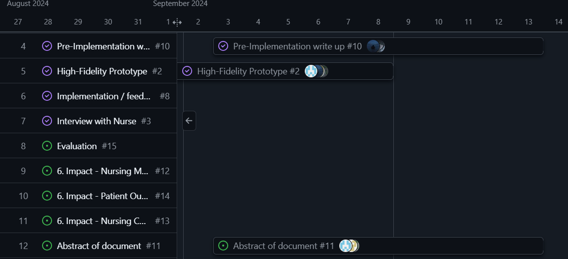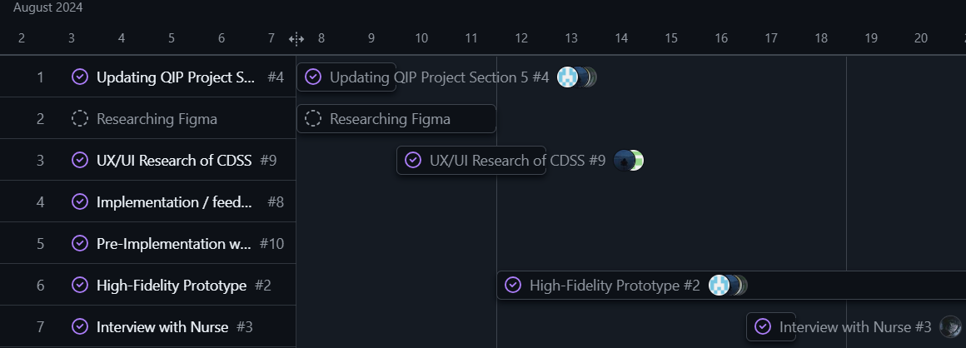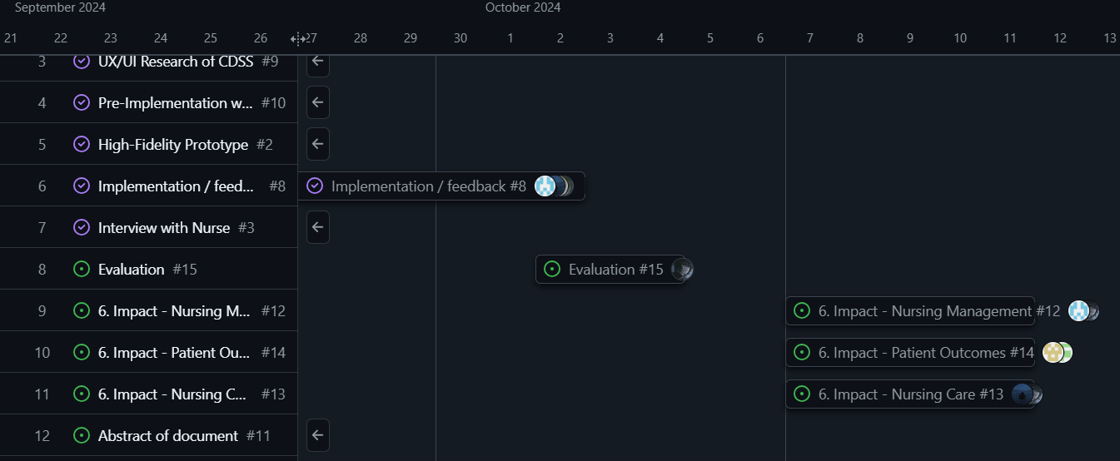

### Recommendations

Figure : Gantt chart of QIP project

In terms of the implementation, it was suggested that as part of the system, there is a feature to view progress on patient health for continuity of care delivered. There should also be input for demographics such as age or gender which would affect the risk assessment process.

We also recommend that there is more engagement from the BIT faculty and university in terms of the healthcare elective module. It would help gain permission to conduct research in hospital wards for the QIP project and have BIT students on a more even ground with the nursing students.

It is concluded from the questionnaire that the implementation of a CDSS would prove beneficial for the oncology wards, especially among the younger nursing staff. Training would need to be in place, but overall, it would assist them in the health risk assessment process. It also raised awareness of a different approach to assessing patients within the oncology wards and the idea that such a system could also be used within other wards. Therefore, with the knowledge and feedback from the interviews, the system would improve health risk assessment and effective health care delivery.

# 6.IMPACT

## Nursing Management

Nursing administration in cancer wards will experience significant changes with the implementation of a Clinical Decision Support System (CDSS). By offering real-time alerts and recommendations based on patient symptoms, nursing managers can enhance their teams' decision-making processes. This data-driven approach fosters a collaborative environment, enabling nurses to assess patient needs more effectively.

The system showed that it can be applied to the strategic, tactical and operational levels of management. On a strategic level, nursing management can implement policies on authorized usage of the system. They can also support quality improvement through monitoring patient treatment and performance. On a tactical level they can provide recommendations to specialists and educate patients on treatment methods. Additionally, the CDSS will help identify specific areas where nursing staff may require further training and development on an operational level, ensuring they are well-equipped to utilize the system efficiently.

As a result, improved workflows and resource allocation are anticipated, leading to enhanced efficiency in delivering patient care. The feedback also promotes continuous learning and improvement in oncology care practices.

## Nursing Care

The implementation of the CDSS will streamline diagnostic and assessment procedures, thereby modernizing nursing care. Nurses will have access to symptom analyses, enabling them to deliver more precise and timely interventions. The ability to monitor patient symptoms and receive treatment recommendations strengthens the nurse-patient relationship, fostering open communication and trust. Moreover, the CDSS encourages nurses to engage in continuous education regarding the latest cancer treatment methods and protocols, ensuring they remain informed about best practices. Ultimately, this expanded knowledge base enhances the nursing staff's capacity to provide high-quality care and effectively address patient concerns, leading to improved patient experiences in the oncology ward.

## Patient Outcomes

Patient outcomes will experience the most significant impact from the implementation of the CDSS. With timely alerts and recommendations, patients are likely to receive earlier diagnoses and more accurate treatment methods, which can greatly enhance survival rates and overall quality of life. The system's capacity to provide personalized treatment suggestions based on symptom analysis ensures that care is tailored to each patient's specific needs. Furthermore, the CDSS enhances patient safety by reducing the likelihood of diagnostic errors and the potential consequences of incorrect diagnoses. As a result, patients can expect a more effective, efficient, and compassionate healthcare experience, ultimately improving their health and increasing their satisfaction with the care they receive.

# 7.CONCLUSION

In conclusion, the implementation of a Clinical Decision Support System (CDSS) in oncology wards offers significant potential to improve the early diagnosis and treatment of cancer patients. Although constraints like limited access to hospitals and time restrictions affected the full implementation of the project, the feedback from nursing students and staff showed strong support for the CDSS. More eventually refinement and training of this system can facilitate decision-making, decrease diagnostic errors, enhance patient outcomes significantly in the field such as oncology.

# References

Agency, I. A. (2023). *Strategic Document Development*. Retrieved from International Atomic Energy Agency: https://www.iaea.org/services/key-programmes/programme-of-action-for-cancer-therapy-pact/strategic-document-development#:~:text=Skip%20to%20main,Terms%20of%20Use

Chieh-Liang Wu, C.-T. K.-J.-C.-C.-H.-D.-H.-A. (2021, April 25). *Implementation of an Electronic National Early Warning System to Decrease Clinical Deterioration in Hospitalized Patients at a Tertiary Medical Center*. Retrieved from National Libray Of Medicine: https://www.ncbi.nlm.nih.gov/pmc/articles/PMC8123282/

Council, S. A. (2020, June). *SANC-Competencies-Oncology-Nurse.* Retrieved from South African Nursing Council: https://www.sanc.co.za/wp-content/uploads/2020/06/SANC-Competencies-Oncology-Nurse.pdf

Council, S. A. (2024). *COMPETENCIES FOR ONCOLOGY AND PALLIATIVE NURSING.* Retrieved from South Africa Nursing Council: https://www.sanc.co.za/wp-content/uploads/2020/06/SANC-Competencies-Oncology-Nurse.pdf

DAVIDS, J. M. (2006, April). *Continuing professional development in nursing.* Retrieved from SunScholor: https://scholar.sun.ac.za/server/api/core/bitstreams/0fcdd91b-ddf7-4732-8c7b-e9add17ff700/content#:~:text=The%20primary%20aim%20of%20continuing,to%20their%20patients%20and%20clients.

Dr. Tiffany Avery, C. M. (2020, August 31). *Understanding Evidence-Based Practice in Oncology.* Retrieved from Nant Health: https://nanthealth.com/resources/articles/evidence-based-practice-in-oncology/#:~:text=Evidence%2Dbased%20practice%20is%20the,clinical%20trials%20for%20similar%20diagnoses.

Jerry, S. (2020, January 09). *DEFINING STANDARDIZATION AND PERSONALIZED CARE*. Retrieved from medicalgps: https://blog.medicalgps.com/defining-standardization-and-personalized-care/#:~:text=Standardization%20in%20healthcare%20is%20often,while%20adhering%20to%20fiscal%20responsibility.

Mary Johnson, R. M. (2024). *Principles of Oncology Nursing*. Retrieved from Scribd Logo: https://www.scribd.com/document/598768495/Principles-of-Oncology-Nursing

Organization, W. h. (2024). *Ensuring quality cancer treatment*. Retrieved from World health Organization: https://www.who.int/activities/ensuring-quality-treatment-for-cancer#:~:text=Cancer%20diagnosis%20and%20treatment%20programmes%20aim%20to%20cure%20or%20considerably%20prolong%20the%20life%20of%20patients%20and%20to%20ensure%20the%20best%20possible%20quali

Programme, N. C. (2023). *National Cancer Control Programme - Latest Information*. Retrieved from National Cancer Control Programme: https://www.hse.ie/eng/services/list/5/cancer/#:~:text=National%20Cancer%20Control%20Programme%20%2D%20Latest,evaluation%20into%20strategies%20and%20actions.

Randa Elsheikh, L. L. (2023, October). *The role of nursing leadership in promoting evidence-based nursing practice*. Retrieved from ScienceDirect: https://www.sciencedirect.com/science/article/abs/pii/S8755722323001035#:~:text=Nurse%20managers%20and%20nursing%20educators,EBP%20implementation%20in%20nursing%20practice.

Staff, C. (2023, December 1). *What Is an Oncology Nurse? And How to Become One*. Retrieved from Coursera: https://www.coursera.org/articles/oncology-nurse

Technicians, N. R. (2024). *National Continued Competency Program*. Retrieved from National Registry Of Emergency Medical Technicians: https://www.nremt.org/Document/nccp#:~:text=HOME,Emergency%20Medical%20Technicians

Town, U. O. (2022). *Evidence Based Practice Guidelines*. Retrieved from University Of Cape Town: https://health.uct.ac.za/childrensnursingunit/EBPG#:~:text=Skip%20to%20main,%7C%20PAIA.

Victoria, D. O. (2021, October 26). *Implementing evidence-based practice.* Retrieved from Department Of Helath Victoria: https://www.health.vic.gov.au/patient-care/implementing-evidence-based-practice

# Annexure A

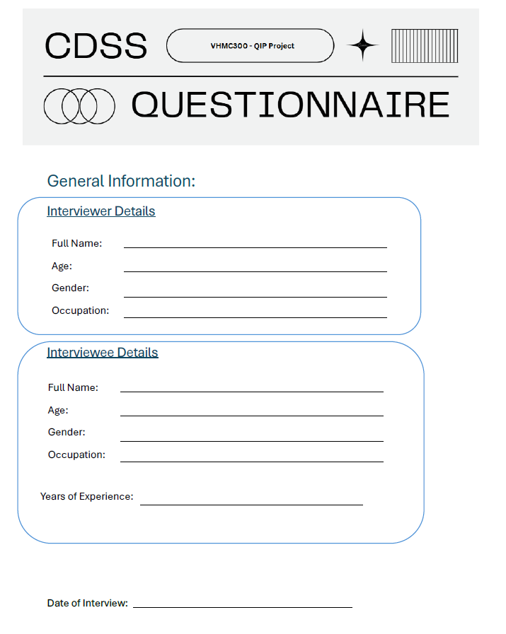

# Annexure B

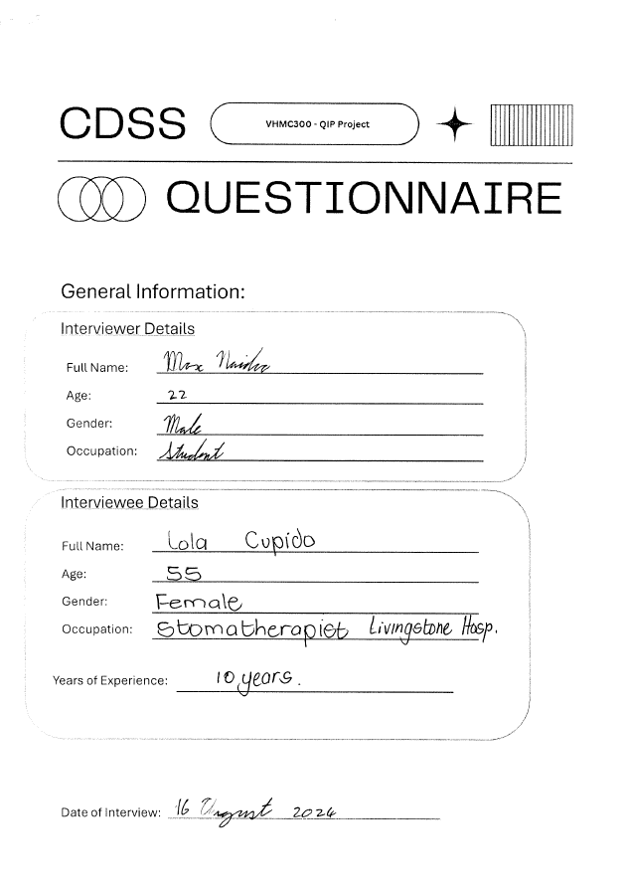

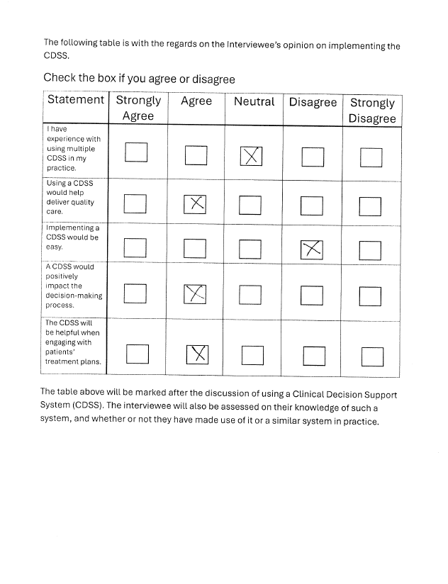

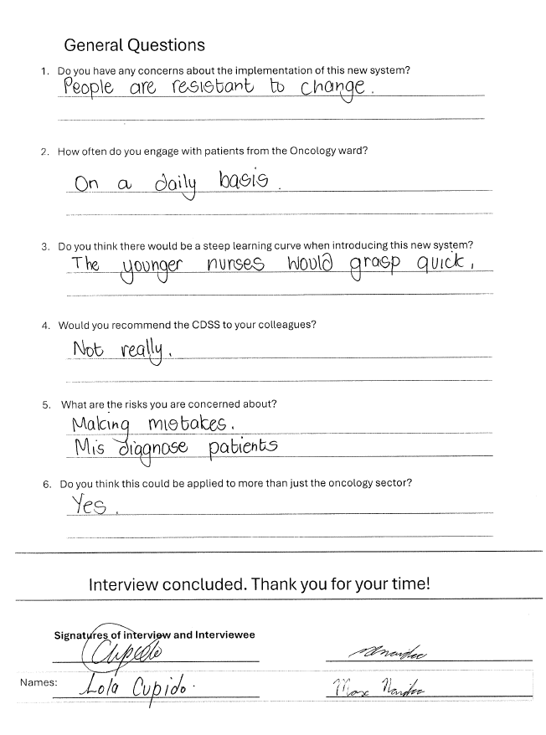

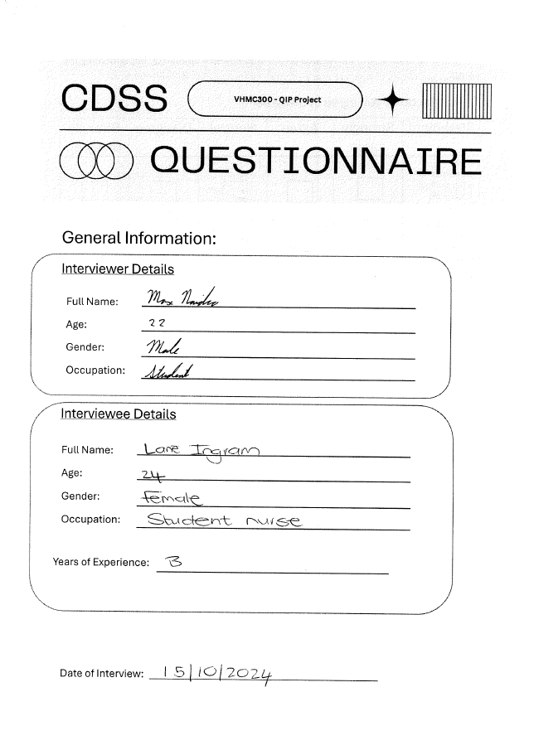

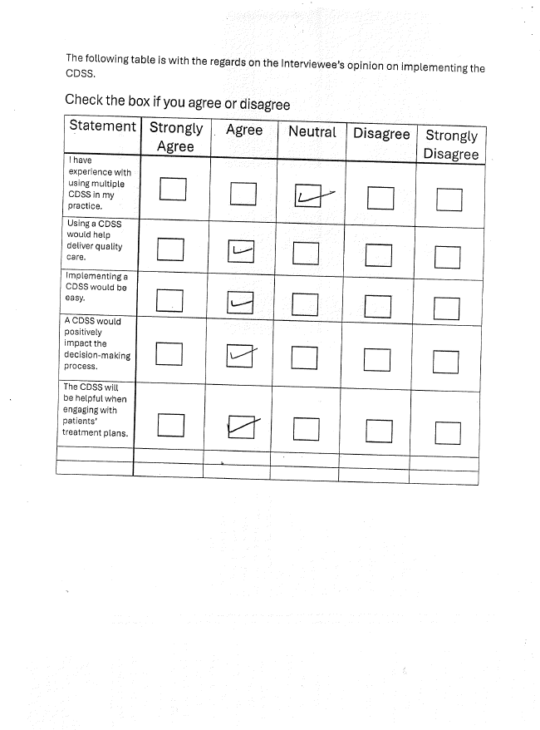

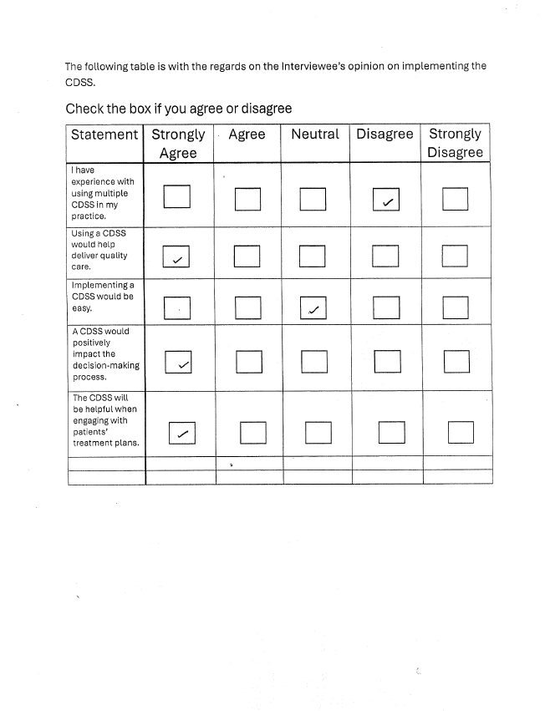

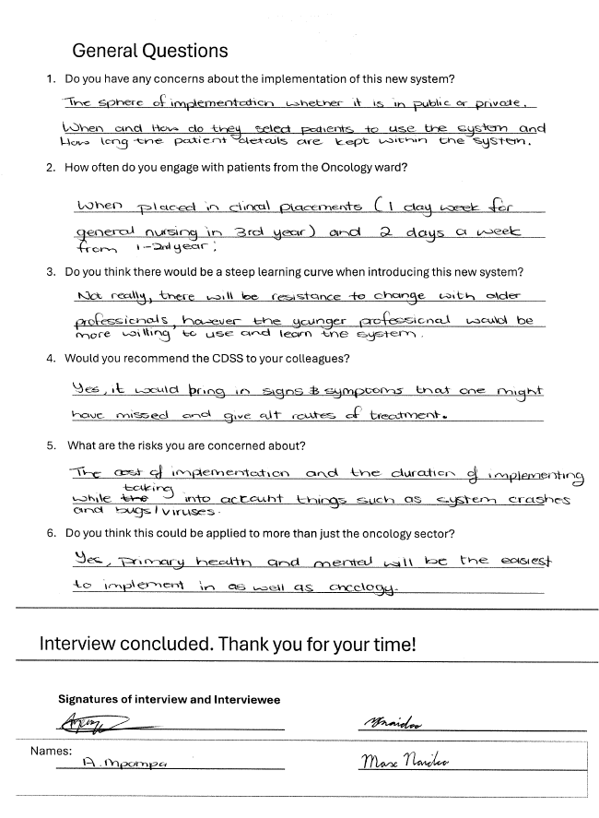

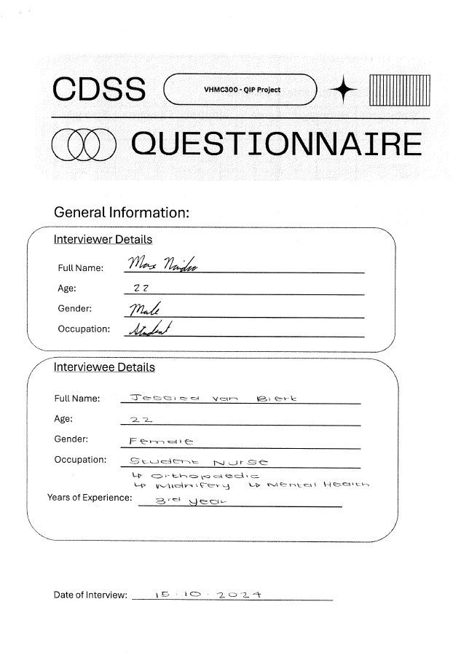

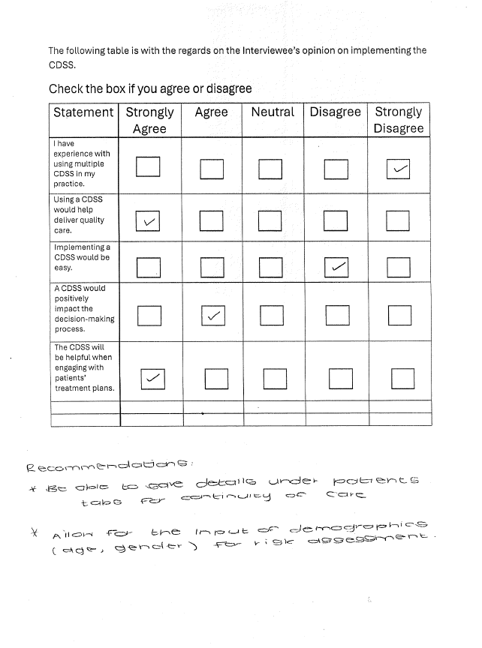

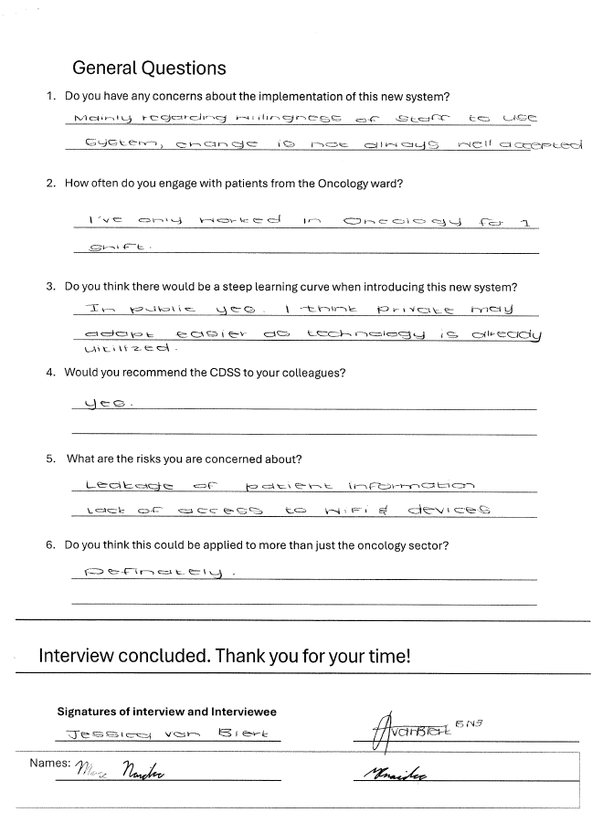

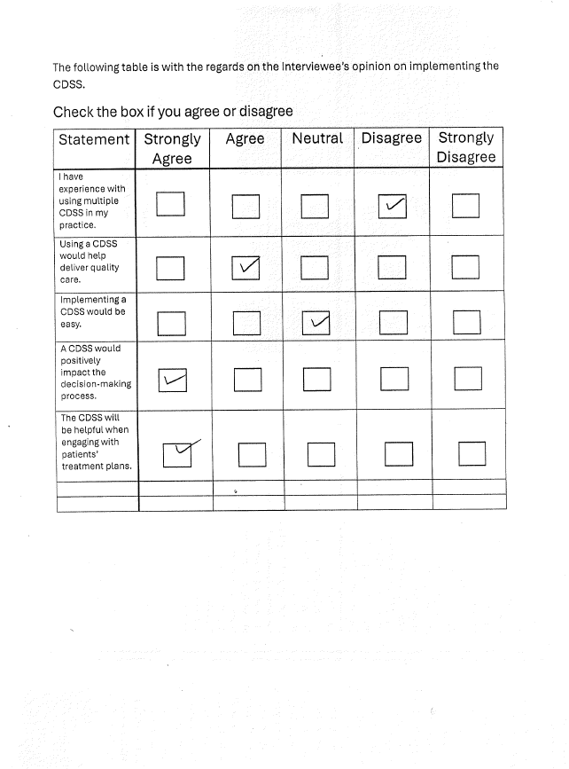

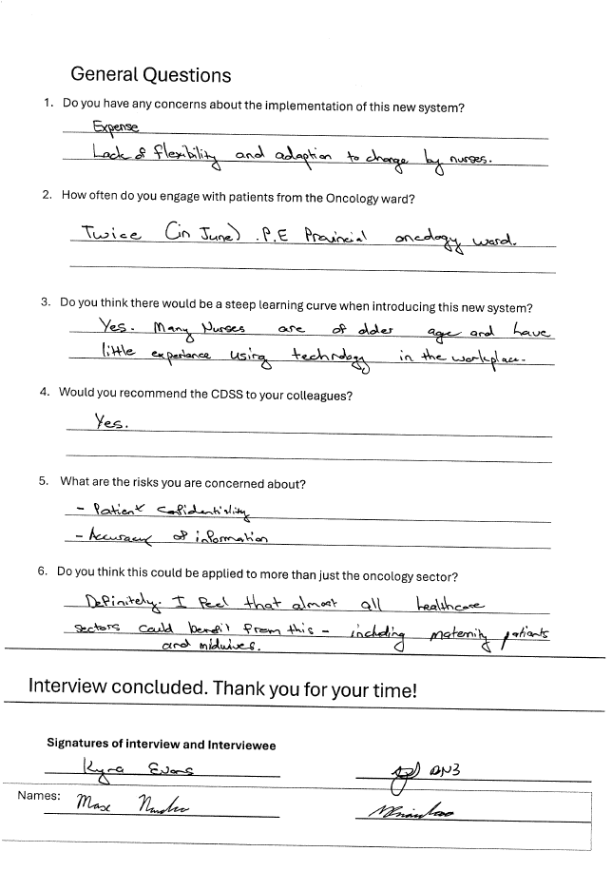

# Annexure C

